Word customising
This section describes methods of changing Word from the initial ‘vanilla’ setup. Customising Word’s interface includes the following:
- Making the New Document Icon default to displaying templates available and not a document based on Normal.dot
- Work menu

Changing the New toolbar button
The initial Word setup does not allow easy access from the toolbar to the new document template dialog box. Clicking the New icon, , opens a document based on Normal.dot as the default template style. This is not very satisfactory. Following the procedure described below will change the action to opening the New dialog box and allowing the user to select the appropriate template.
To change the button action, do the following:
- Start Word and create a new document based on Normal.dot (default).
- Right click on the toolbar, click Customize.
The Customize dialog box appears.
- Select the Commands tab.
- From the Save In dropdown list, chose Normal.
- In the Commands area, click and drag the New… icon to the toolbar.
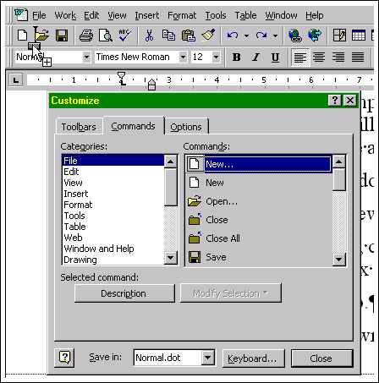
Figure 1 – Selecting and dragging the New icon
- Release the mouse button, after positioning the new icon beside the existing icon.
- Click and drag the original icon off the toolbar.
- Click Close.

Work menu
The Recent Files list spares you the hassle of navigating the Open dialog box for recently opened documents. Convenient though the Recent Files list may be, you'll frequently find yourself looking in the Open dialog box for documents whose 15 minutes of fame on the Recent Files list has expired. The Work menu provides quick access to documents you specify rather than documents you've recently opened.
Adding the Work menu
- Start Word
- Select Tools → Customise → Commands tab.
- From the Save In list, select Normal.dot.
- In the Categories area, select Built-In Menus.
- In the Commands area, click and drag Work to a convenient position on the Word menu bar.
- Click Close.
Using the Work menu
After adding the Work menu, it contains a single command, Add To Work Menu.
When you use this command, Word adds a shortcut to the active document on the Work menu for future access. The document will remain on the Work menu until removed by the user.
Note: The Work menu is a dynamic display. The menu displays the document and entire path name, if the document is not in the current directory; otherwise, it only displays the document name. When the document name or location is changed the Work menu does not update to reflect the change. You must delete the Work menu entry and add the document again to the Work menu.
Removing items from the Work menu
To remove an item from the Work menu:
- Press Ctrl + Alt + –.
The cursor changes to a minus symbol.
- From the Work menu, click on the document to be removed.
The document entry is removed from the Work menu and the cursor returns to normal.

Shortcut keys
The following table lists keyboard shortcuts that you are likely to find useful:
Selecting, moving the cursor and repeating commands
Action | Keystroke
Return to the last edit/entry made in the document during the current Word session | Shift+F5
Select (highlight) | Hold Shift and move the cursor using the arrow keys
Select a paragraph | Double click in the left margin.
Copy selected text | Ctrl+Insert or Ctrl+C
Paste | Shift+Insert or Ctrl+V
Delete selected text | Delete or Shift+Delete  Note: If Shift+Delete is used, you can use Ctrl+V or Shift+Insert to paste the deleted text elsewhere.
Repeat last command or action | F4
Undo last command | Ctrl+Z
Toggle between open Word Documents | Ctrl+F6
Close currently displayed Word Document | Crtl+F4
Table 1 –Selecting, moving the cursor and repeating commands
Finding and Replacing
Action | Keystroke
Open Find/Replace dialog box | Ctrl+F (Find tab selected)  or Ctrl+H (Replace tab selected)
Repeat last search  Note: Does not require Find/Replace dialog box to be displayed | Shift+F4
Table 2 – Finding and Replacing
Formatting
Action | Keystroke
Quickly access Style drop-down combo box.  Then just type the style name and press Enter. | Ctrl+Shift+S
Quickly access Font drop-down combo box.  Then just type the Font name and press Enter. | Ctrl+Shift+F
Quickly access Font size drop-down combo box. Then just type the point size and press Enter. | Ctrl+Shift+P
Bold | Ctrl+B
Italics | Ctrl+I
Insert a line break, ↵ (not a Paragraph break) | Shift+Enter
Insert a page break | Ctrl+Enter
Insert a Column Break | Ctrl+Shift+Enter
Apply Heading 1 Style | Ctrl+Alt+1
Apply Heading 2 Style | Ctrl+Alt+2
Apply Heading 3 Style | Ctrl+Alt+3
Apply Normal Style | Ctrl+Shift+N
Table 3 – Formatting
Tables
Action | Keystroke
Insert a tab in a table cell | Ctrl+Tab
Move from cell to cell in a table | Tab – move forward  Shift+Tab – move in reverse
Defining column widths | Alt+drag on table column marker, the ruler displays the column widths. Drag to the appropriate width.
Table 4 – Tables
Writer’s Tool

To add some nonsense or ‘greeking’ text:

Type:

=rand(number of paragraphs, number of sentences)
Then press Enter.
For example, =rand(5,7)

This will create five paragraphs containing seven sentences. The sentence is the standard:
The quick brown fox jumps over the lazy dog

All Word menu and keyboard commands
- Click on the Tools Menu
- Select Macros
- Click Macros, the Macros dialogue box displays.
- In the Macros dialogue box, Macros In field select Word Commands.
- Select ListCommands from the list of macro names.
- Click Run. The List Commands dialog box displays.
- Select All Word Commands and click OK.
- Word will generate a table in a new document.
Note: this document is approx 19 pages long.

Scroll through this document to find the standard keyboard shortcuts for the commands you use regularly.

Ctrl+Insert can be used in most Windows applications and even within dialog boxes.
Shift+Insert can be used in most Windows applications and even within dialog boxes.
Shift+Delete can be used in most Windows applications and even within dialog boxes.

